TFS #99229

Primary for 1098 Is Not Saving After Deleting an Address

Kevin Geissler

11/21/16

Table of Contents

TFS # 1

Description 2

Testing Notes 2

Screen Shots and Steps Taken 2

# Description

KPG 11/18/2016 - The primary address for the 1098 is not saving by default after deleting the address indicated as the primary.

[Video can be seen here](https://extranet.financialpartners.com/Workspaces/Shared/cwenhance/FPIDocuments/2016%20Q4%20TFS%20Testing%20Docs/Location%20Panel%20INC/Primary%20Not%20Saving.wmv)

Steps to recreate:

1. Add 2 or more addresses with either Add Location w/ New Address OR Add Location w/ Selected Address

2. Delete all rows

3. Add a row for an address

4. Click Next - The Primary for 1098 radio button is not selected by default

# Testing Notes

## Screen Shots and Steps Taken

1. Added several existing addresses.

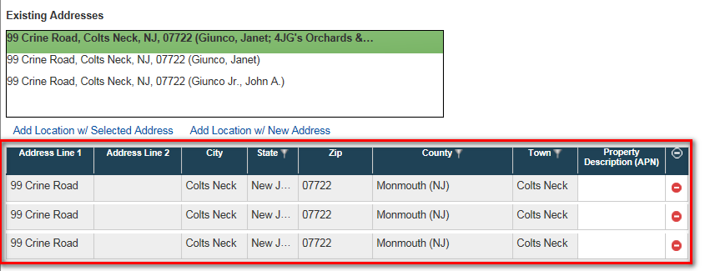

1. Deleted all the address rows.

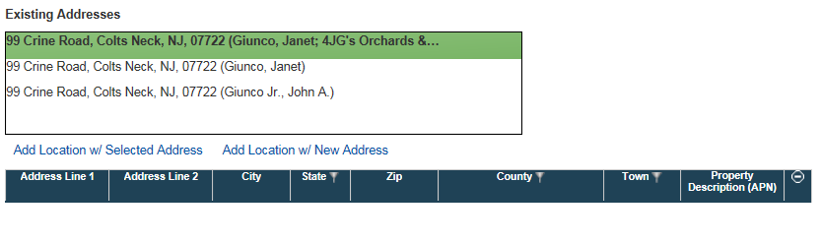

1. Added the address row back

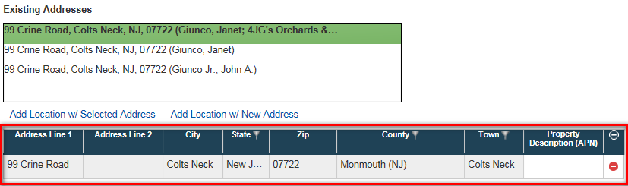

1. Clicked Next and the Primary for 1098 is indicated as expected.

